**A CRM APPLICATION FOR SCHOOLS/COLLEGES**

1. INTRODUCTION

* 1. PROJECT OVERVIEW:

This project aim is to maintain and manage the school problems which further can be modified based on the requirements.

We Created

* School Management App
* Objects and fields for App.

1.2 PURPOSE

* This is customer relationship management, to help you tracking all of your constituent relationship management, from prospects and students.
* The status of the students is easily available for students.

2. PROJECT DEFINITION AND DESIGH THINKING

2.1 EMPATHY MAP

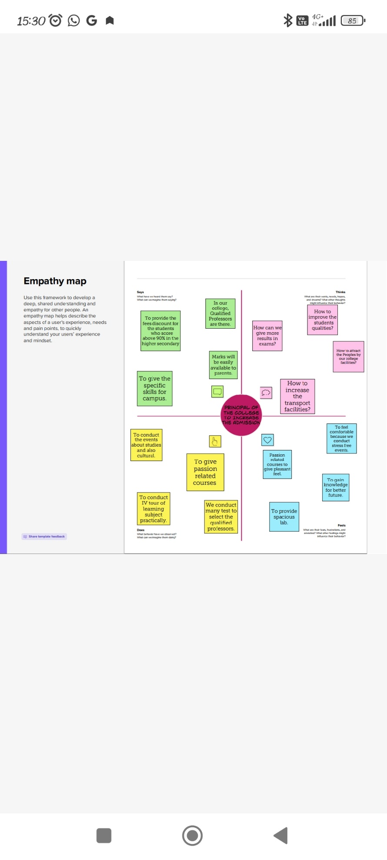 2.2 IDEATION AND BRAINSTORMING MAP

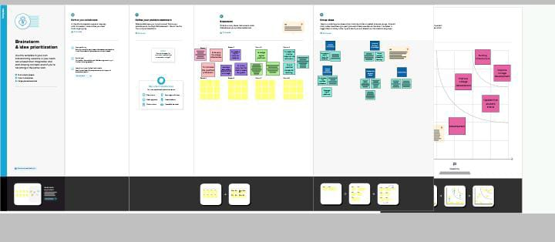

3.1 Data Model

|  |  |
| --- | --- |
| Object Name | Field in the object |
| School  Student  Parent | |  |  | | --- | --- | | FIELD LABEL | DATA TYPE | | Address | Text Area | | District | Text Area | | Highest Marks | Roll-up Summary  (MAX Student) | | No. of Students | Roll-up Summary  (COUNT Student) | | Phone Number | Phone | | School Websites | Text Area | | State | Text Area |  |  |  | | --- | --- | | FIELD LABEL | DATA TYPE | | Class | Number | | Marks | Number | | Phone Number | Phone | | Results | Pick List | |  |  |  |  |  | | --- | --- | | FIELD LABEL | DATA TYPE | | Parent Address | Text Area | | Parent Number | Phone | |

3.2 ACTIVITY AND SCREENSHOT

Milestine-2

School Object:

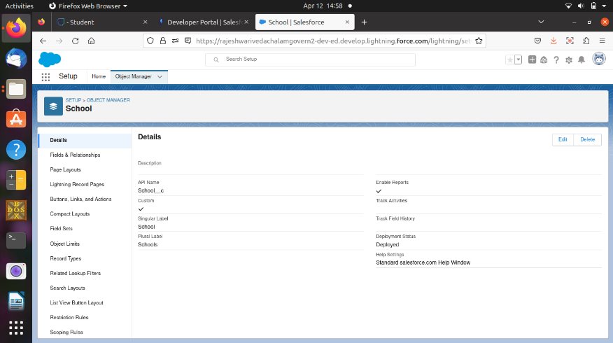

Student Object:

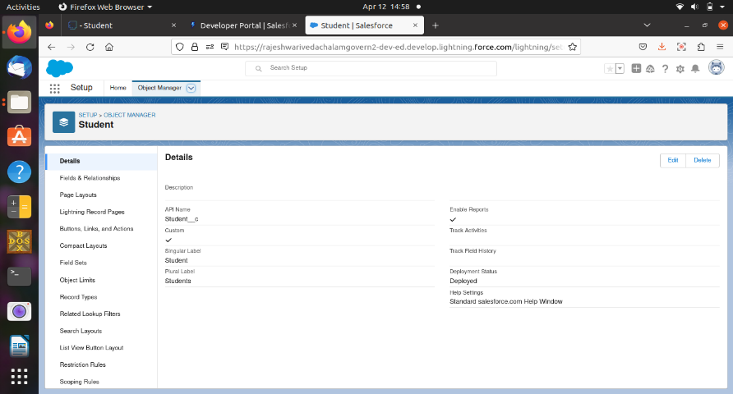

Parent Object:

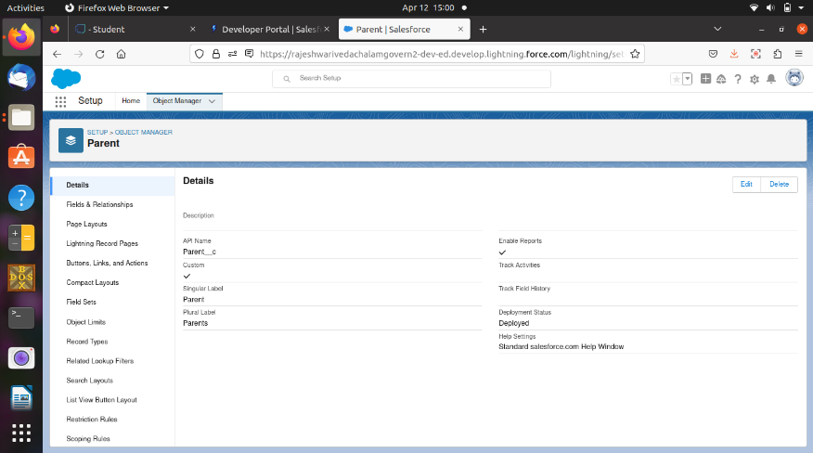

Milestone-3

Creation for Lighting app:

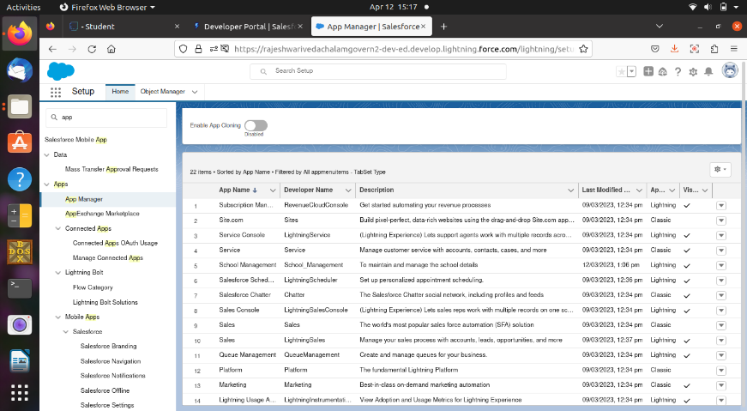

Milestone-4

Creation of fields and Relationship:

School Field:

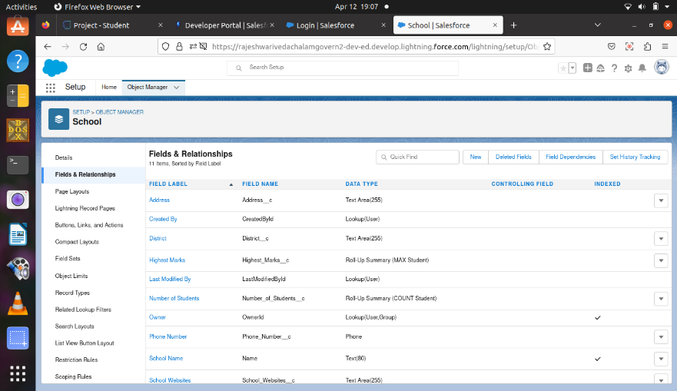

Student Field:

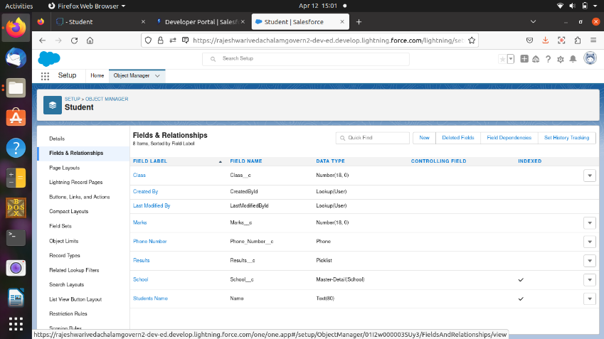

Parent Field:

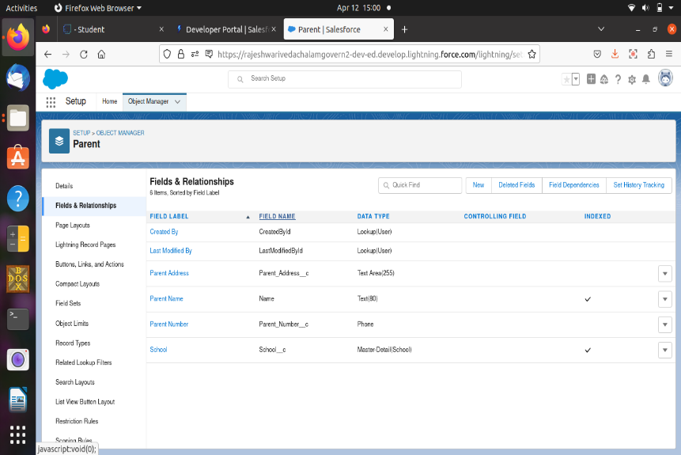

Milestone-5

Creation of Profiles:

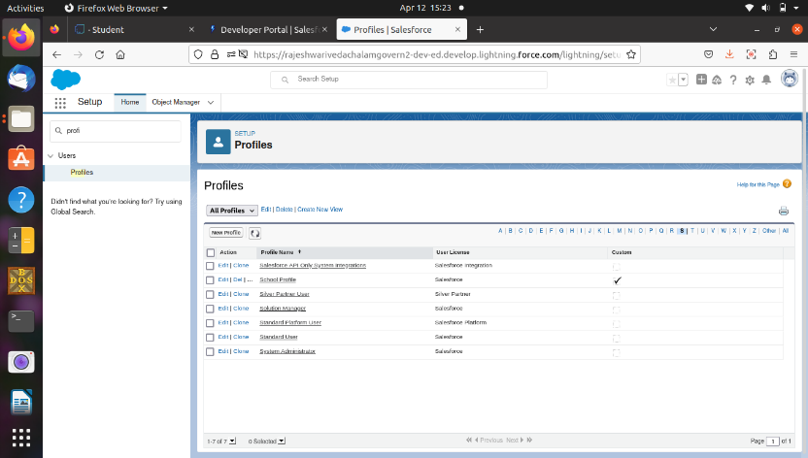

Milestine-6

Creation of Users:

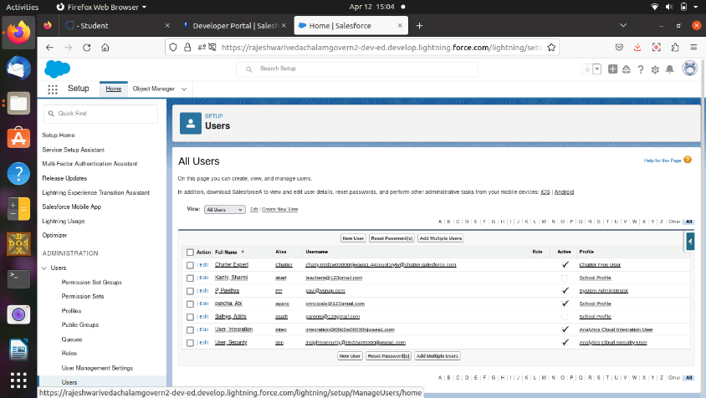

Milestone-7

Permission set 1:

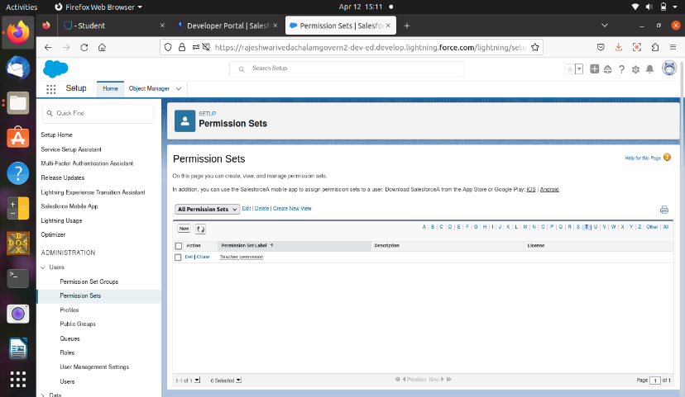

Permission set 2:

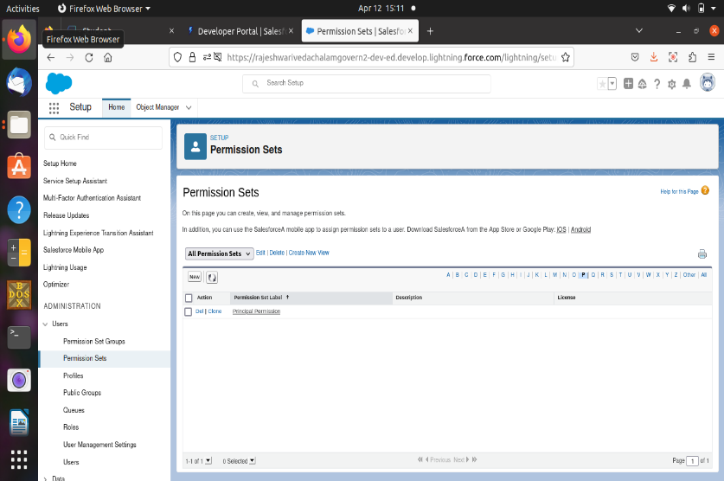

Milestone-8

Creation of Reports:

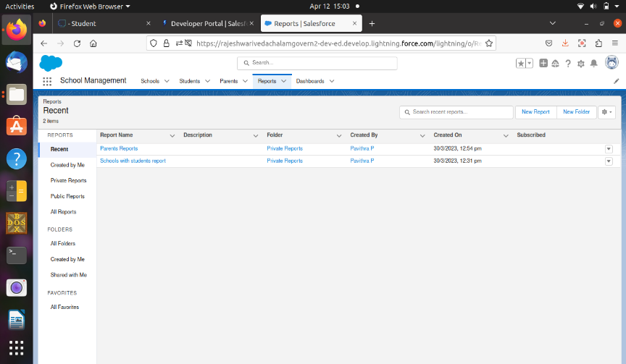

4. TRAILHEAD PROFILE PUBLIC URL:

Team Lead – <https://trailblazer.me/id/pinky02>

Team member1: <https://trailblazer.me/id/sguna89>

Team member2: <https://trailblazer.me/id/vidhya14>

Team member3: <https://trailblazer.me/id/nnive21>

5. ADVANTAGES AND DISADVANTAGES:

* Having huge amounts of data on customer interaction enables an organization to build up a clearer picture of its customers.
* All gathered data is stored and maintained as one centralized location in CRM, which can be easily accessible to see the information.
* Not suitable for every business
* They are many security issues with CRM such as data costs and data being hacked by someone.

6. APPLICATIONS OF CRM:

* This project helps you to maintain and manage the school related problem.
* This project aim is to provide real-time knowledge for all the students who have basic knowledge of salesforce.

7. FUTURE SCOPE:

* CRM Software helps to generate a progress report on the ongoing tasks in your enterprises.
* In future CRM Software is used to track all the customers data and records.

8. CONCLUSION:

* To created new object and fields.
* It was observed that the presence of effective parent relationship management in the university increases the level of student report patronage intention.